Invitation & application guidelines

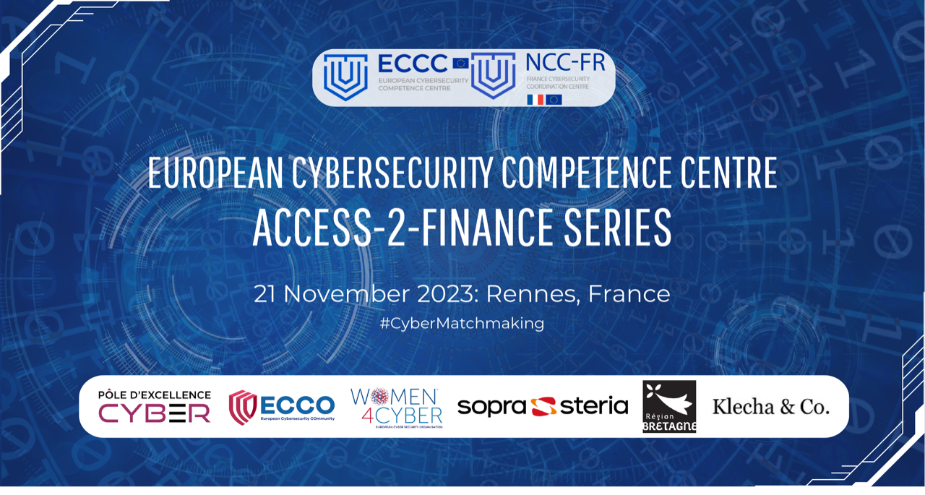

Don't miss your chance to meet with fellow cybersecurity entrepreneurs and industry leaders and attend the pitches & B2B meetings

The European Cybersecurity Competence Centre (ECCC), the French National Coordination Centre (NCC-FR), the Women4Cyber Foundation, Sopra Steria, Pole d’Excellence Cyber, Région Bretagne, and Klecha & Co., have the pleasure of inviting you to the French edition of the ECCC Access-2-Finance series, powered by ECCO, scheduled on the 21 November 2023 in Rennes, France.

The most promising European cybersecurity start-ups and scale-ups will have a chance to pitch their innovative cybersecurity solutions and hold B2B meetings with the leading investors and corporates from around Europe. The French edition of the ECCC Access-2-Finance series will be organised back-to-back with the European Cyber Week (21 –23 November), and will take place in-person.

SUBMISSION DEADLINE: 27 October COB

ECCC cybersecurity business matchmaking events are designed to:
- Cover different investment phases, ranging from seed to strategic investment and M&A,
- Give exposure to potential corporate customers and business partners.

ECSO STARtup Award 2023. The two best cybersecurity companies participating in the French edition of the ECCC Access-2-Finance series will be nominated to compete for the ECSO STARtup Award 2023. Nominees will be selected by the local jury and will be invited to participate in the final competition, which will be held early 2024. During the final ceremony, nominees will pitch to the European jury and will have a unique opportunity to present themselves to high-level investors, corporate executives and cybersecurity experts. For more information, click here.
Women4Cyber Entrepreneurship Award. ECSO and the Women4Cyber Foundation joined forces to acknowledge and celebrate women leaders in the cybersecurity field, as well as companies that are actively working towards achieving gender equality. This collaborative effort aims to shine a spotlight on the invaluable contributions of women in cybersecurity while promoting and supporting organizations that prioritize diversity and gender balance. Cybersecurity companies (co) founded by women and/or with women on the board and/or with at least 30% of women in the workforce and/or demonstrating a commitment to increase female participation are eligible to apply for the W4C Entrepreneurship Award. For more information, click here.

See the ‘Application Roadmap’ on the following page. Good luck with your submission!

APPLICATION ROADMAP
The selection of the participating start-ups and scale-ups is based on the most innovative solutions to be presented to investors and corporates

FILL IN THE APPLICATION FORM
You can download it from the
event page: “insert event page”

PREPARE 5-7 SLIDES PITCH DECK WHICH INCLUDES:
- Unique value proposition: problem, solution, product
- Market & Go-to-Market strategy
- Business model & use of proceeds
- Competition on the market
- Your Top 3 competitive advantages
- Team size

SEND APPLICATION FORM & PITCH DECK TO:
“Insert name and e-mail of person”

DEADLINE:
27 October COB.

EVALUATION & SELECTION
“insert date”
The Selection Committee composed of European cybersecurity experts, as well as representatives from The European Cybersecurity Competence Centre, French National Coordination Centre (NCC-FR), the Women4Cyber Foundation, Sopra Steria, Pole d’Excellence Cyber, Region Bretagne, and Klecha & Co.

SELECTED START-UPS & SCALE-UPS ANNOUNCED
Applicants will be individually informed about the results by “insert date”

ECCC ACCESS-2-FINANCE SERIES
21 November 2023| Rennes, France

Stage introduction of the investors and corporates
Pitches by the pre-selected European cybersecurity start-ups and scale-ups
B2B meetings among start-ups, scale-ups, investors and corporates

About the organisers

European Cybersecurity Competence Centre (ECCC)
The European Cybersecurity Competence Centre (ECCC) aims to increase Europe’s cybersecurity capacities and competitiveness, working together with a Network of National Coordination Centres (NCCs) to build a strong cybersecurity Community.
The Centre and the Network will pool resources from the EU, its Member States, as well industry, academia and other stakeholders, to improve and strengthen technology and industrial cybersecurity capacities, enhancing EU's open strategic autonomy.
The Centre will manage 2021-2027 EU funding from the Digital Europe and Horizon Europe Programmes, as well as contributions from Member States. In 2021-2022 the EU is investing more than €300 million in topics such as cyber threat intelligence, cybersecurity upgrades in SMEs, cyber in the health sector, cyber secured hardware and operating systems, or training and skills.
The Governing Board of the Centre is composed of representatives from the Member States (27 members), the Commission (2 members) and the European cybersecurity agency-ENISA (1 permanent observer). In February 2022, the Governing Board elected Pascal Steichen, from Luxembourg, as its Chair, and Katarzyna Prusak-Gorniak, from Poland, as its Vice-Chair. The European Commission is running the Centre until it can operate fully independently, with Miguel González Sancho currently serving as Interim Executive Director of the Centre.
For more information on the Centre, including future funding and job opportunities, follow the Centre on Twitter and on the web.

